BAHRIA UNIVRSITY ISLAMABAD

INTRODUCTION TO DATA SCIENCE

BSCS 6B

Instructor: DR. ARIF UR REHMAN

PROJECT SUBMISSON – THIRD DELIVERABLE

Group Members:
SYED MUHAMMAD HAMZA SULTAN – (01-134232-178)
MUHMMAD SHAHZAIB FAROOQ – (01-134232-132)

Initial Project Report
Software Requirements Classification using NLP Techniques

---------------------------------------------------------------------------------------------------------------------
1. Project Title & Introduction

  - Introduction

In modern software engineering, requirements play a critical role in defining system functionality and quality expectations. These requirements are categorized into Functional Requirements (FR) and Non-Functional Requirements (NFR). Manual classification of such requirements is time-consuming, error-prone, and inconsistent across large-scale projects.

This project aims to develop a data-driven solution that automates the classification of software requirements using Natural Language Processing (NLP) and machine learning techniques. By using textual data, the system will assist developers and analysts in efficiently identifying requirement categories, ultimately improving software design and documentation processes.

  - Problem Statement

The core problem addressed in this project is:
How can textual software requirements be automatically classified into functional and non-functional categories (and their subcategories) using data science techniques?

This problem involves challenges such as:
- Handling unstructured textual data
- Identifying patterns in requirement descriptions
- Managing overlapping categories (multi-label classification)
- Ensuring model generalization across different projects

  - Dataset Justification

The project utilizes the PROMISE dataset specifically a relabeled version suitable for requirement classification tasks.
The selection of this dataset is justified based on:
- Open Availability: Freely accessible and widely used in academic research
- Domain Relevance: Specifically designed for software engineering and requirements analysis
- Rich Annotation: Includes labels for functional and multiple non-functional categories (e.g., security, usability, performance)
- Real-world Applicability: Derived from actual software projects, ensuring practical relevance

Thus, the PROMISE dataset serves as a reliable foundation for building and evaluating NLP-based classification models.
2. Objectives & Initial Methodology

2.1 Project Objectives

The primary objectives of this project are:
- EDA - To analyse and understand software requirements using data science techniques.
- Data Cleaning & Feature Engineering - To extract meaningful insights from textual requirement data.
- Model Building & Evaluation - To develop a classification model that distinguishes between functional and non-functional requirements.
- Deployment - To design a simple prototype (web dashboard) for visualizing insights and predictions.

2.2 Proposed Methodology

The project follows a structured data science pipeline:

1. Problem Definition
- Defining the objective: Categorizing textual software requirements into Functional (FR) and Non-Functional (NFR/Quality) classes.
- Establishing the scope of the NLP classification task.

2. Data Collection
- Utilizing the openly available PROMISE repository dataset for software requirements.
- Loading and structuring the raw text data for analysis.

3. Data Understanding & Exploration (EDA)
- Understanding dataset structure and category distributions.
- Identifying patterns, class imbalances, and complexity relationships (e.g., distinguishing between Pure Functional, Pure Quality, and Mixed requirements).

4. Data Cleaning & Preprocessing
- Text cleaning (removal of noise, punctuation, and standard English stop words).
- Tokenization and text normalization (e.g., lowercasing).
- Handling missing, noisy, or inconsistent values within the dataset.

5. Feature Engineering & Selection
- Conversion of raw text into a numerical format using TF-IDF (Term Frequency–Inverse Document Frequency).
- Representing textual importance and vocabulary frequencies for the machine learning models.

6. Model Building
- Application of machine learning classification algorithms, such as:
  - Logistic Regression
  - Support Vector Machines (SVM)
  - Naive Bayes

7. Model Evaluation & Validation
- Evaluating model performance using robust metrics including Accuracy, Precision, Recall, and F1-score.
- Validating the model's ability to handle potentially imbalanced textual classes.

8. Deployment
- Development of a simple Streamlit web dashboard prototype.
- Creating an interactive interface for displaying visualizations, insights, and real-time model predictions on new requirement text.

9. Monitoring & Maintenance
- Future Scope: Monitoring the model for accuracy degradation over time.
- Maintaining the system by potentially updating the model with new, unseen software requirement data as it becomes available.

3. Exploratory Data Analysis (EDA) Overview
3.1 What is EDA?
Exploratory Data Analysis (EDA) is a fundamental step in the data science pipeline used to summarize, visualize, and understand datasets before applying machine learning models. It helps in identifying patterns, anomalies, and relationships within the data.

3.2 EDA Decision Strategy
A data scientist determines the appropriate EDA techniques by asking:
Is the dataset balanced? → Use bar charts
Are text lengths consistent? → Use box plots / histograms
Are there overlapping categories? → Use stacked visualizations
Are there dominant words or features? → Use word frequency plots
This structured approach ensures that insights are both relevant and actionable.

4. EDA Implementation & Insights (Function-by-Function)

4.1 Initial Data Inspection The first step involves understanding the dataset structure using built-in Pandas functions:
- shape → Determines the total number of rows and columns.
- info() → Displays data types and memory usage.
- nunique() → Identifies the number of unique values per column.
- isnull().sum() → Detects missing values across the dataset.
This step ensures that the dataset is clean, consistent, and ready for further analysis.
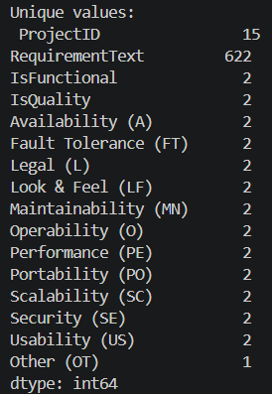
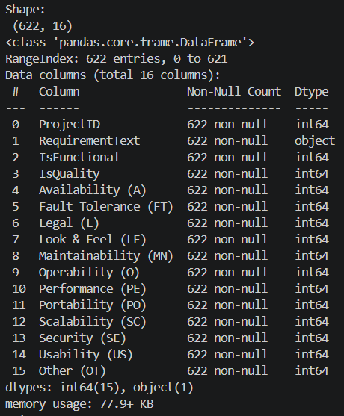

Insight: The dataset appears structurally consistent with minimal missing values, indicating that preprocessing requirements for missing data may be limited. The presence of multiple categorical columns confirms a multi-label classification problem.

4.2 Category Distribution Analysis The code computes the sum of each category column to determine how frequently each requirement type appears across the entire dataset. A bar chart is plotted to visualize:
- The overall distribution of Functional vs. Non-Functional requirements.
- The frequency of specific subcategories such as Security (SE), Usability (US), and Performance (PE).
Additionally, grouping the data by ProjectID allows for the comparison of category distributions across different software projects using a stacked bar chart.
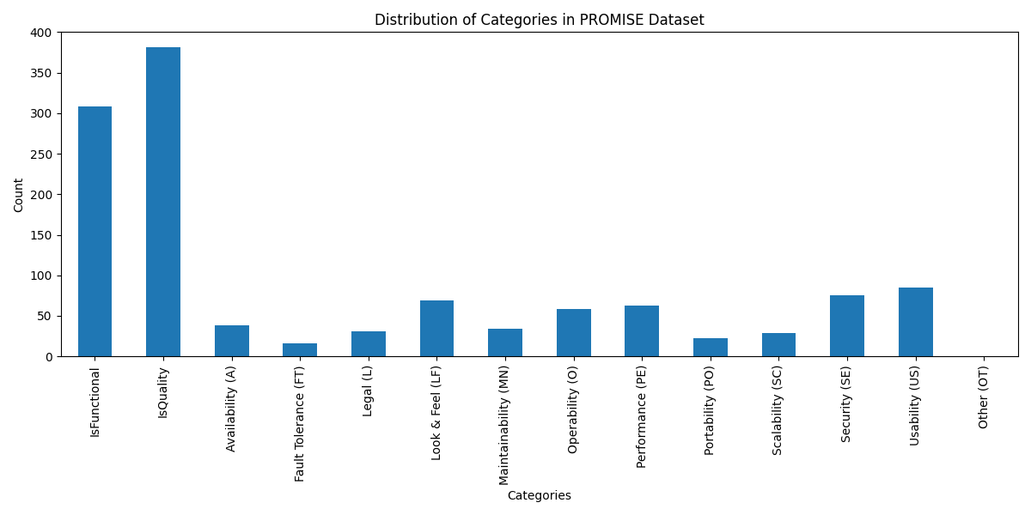

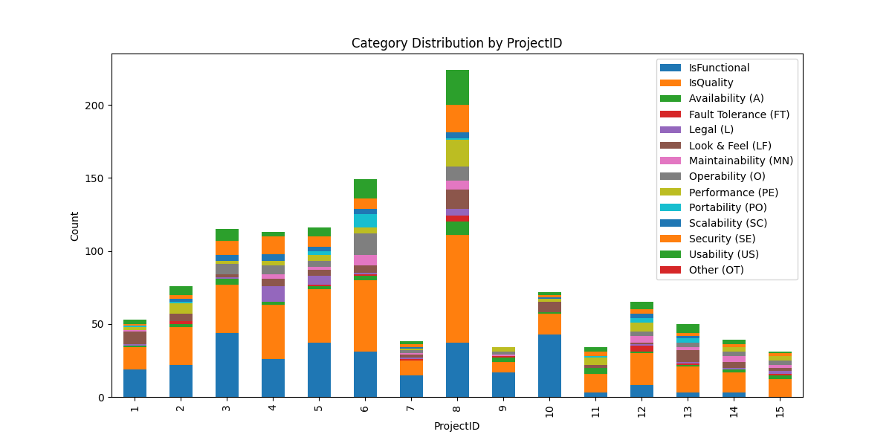

Insight: Certain categories (e.g., Functional and Quality) heavily dominate the dataset, indicating a potential class imbalance. Furthermore, the stacked chart reveals that different projects have distinct requirement priorities, which may introduce variance when training the classification model.

4.3 Category Overlap / Complexity Analysis To analyse the structural complexity of the requirements:
- A new column CategoryCount is created to calculate the total number of labels assigned to each specific requirement.
- Requirements with the highest counts are isolated as "complex samples."
- Pure functional requirements (where only the FR label is active) are isolated as "simple samples."
- A stacked horizontal bar chart is plotted to visually compare the label overlap between these simple and complex requirements.
This step highlights the highly multi-label nature of the dataset.

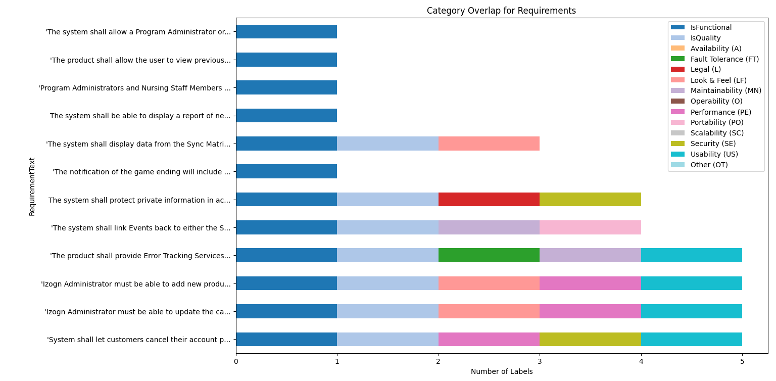

Insight: A significant portion of the requirements belong to multiple categories simultaneously. This confirms that the problem is not a simple binary classification task but involves overlapping classes, which will increase the required complexity of the eventual machine learning model.

4.4 Word Count & Classification Complexity Analysis To determine if document length correlates with the type of requirement, a lambda function is used to compute the number of words in each text string: lambda x: len(str(x).split())
To ensure robust analysis, the dataset is systematically divided into three distinct buckets:
- Purely FR: Requirements that are strictly Functional (Functional = 1, all NFR tags = 0).
- Purely NFR: Requirements that are strictly Non-Functional (Functional = 0).
- Mixed (FR + NFR): Requirements that possess both a Functional tag and at least one Non-Functional tag.
The distribution of these lengths is visualized using a Histogram with a Kernel Density Estimate (KDE) curve, and the exact mathematical averages are plotted side-by-side on a bar chart.

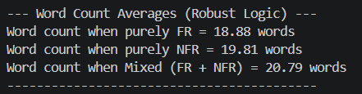
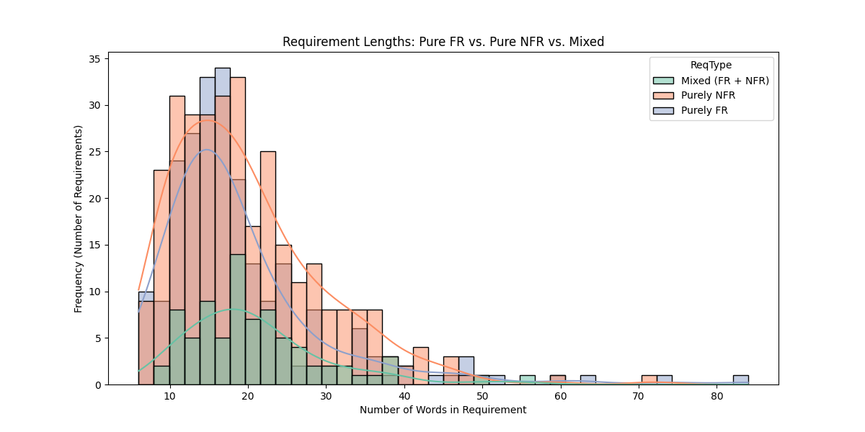

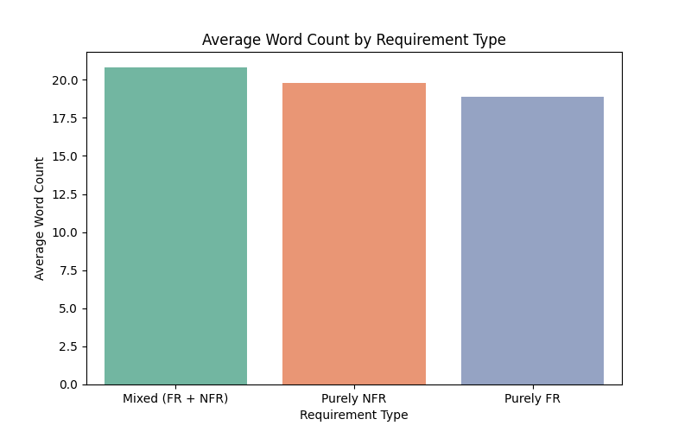

Insight: The distribution analysis reveals minimal significant variation in average word counts across Pure FR, Pure NFR, and Mixed requirements. Because document length remains relatively uniform regardless of the class, it cannot serve as a strong predictive attribute for the model. This critical finding indicates that the classification pipeline cannot rely on structural length and must instead focus on semantic differences by extracting unique vocabulary and term frequencies (TF-IDF) in the subsequent preprocessing phase.

-----THIRD DELIVERABLE CONTUNIATION-----
5. Data Cleaning & Preprocessing
5.1 Objective
The purpose of this step is to clean and standardize the raw requirement text so it can be used effectively in machine learning models. Since the dataset contains natural language, it may include noise such as punctuation, stop words, and inconsistent formatting.

5.2 Implementation
The cleaning process is applied step-by-step on the RequirementText column, and the result is stored in a new column called CleanedRequirementText.

Steps Performed:
- Lowercasing
All text is converted to lowercase to maintain uniformity and avoid duplicate representations of the same word (e.g., “System” vs “system”).

- Removing Punctuation
Special characters and punctuation are removed using regular expressions to keep only meaningful words.

- Removing Stop Words
Common English words (such as the, is, and, in) are removed using the NLTK stopwords list, as they do not contribute to classification.

- Tokenization
The text is split into individual words (tokens) for processing.

- Replacing Numbers with <NUM>
Instead of deleting numbers, they are replaced with a placeholder token <NUM> to preserve their presence without adding noise.

- Removing Extra Spaces
Any unnecessary whitespace is removed to keep the text clean.

- Lemmatization
Words are reduced to their base form (e.g., “running” → “run”) using WordNet Lemmatizer to improve consistency.

- Removing Duplicates
Duplicate rows based on cleaned text are removed to avoid bias in training.

- Removing Empty Rows
Any rows that become empty after cleaning are dropped.

- Index Reset
The dataset index is reset after removing rows.

5.3 Output Verification
A side-by-side comparison of original and cleaned text is printed to verify the preprocessing step.

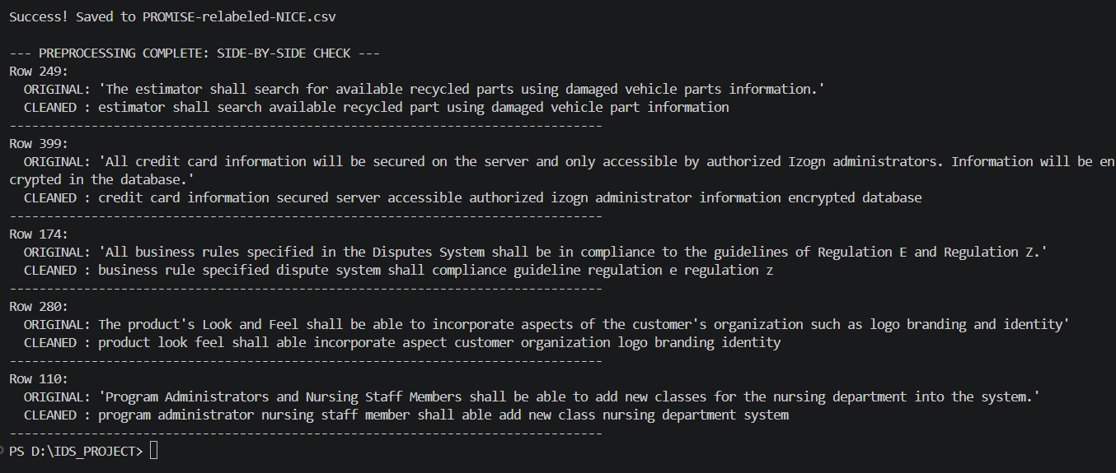
5.4 Insight
The cleaning process significantly improves text quality by removing noise and standardizing words. This ensures that the model focuses only on meaningful information rather than irrelevant variations.

6. Feature Engineering & Selection
6.1 Objective
The goal of this step is to convert cleaned text into a numerical format that machine learning models can understand.

6.2 Implementation (TF-IDF Vectorization)
The cleaned text is transformed into a matrix using TF-IDF (Term Frequency – Inverse Document Frequency).

Key Steps:
- Loading Cleaned Data
The dataset with CleanedRequirementText is loaded.

- Handling Missing Values
Rows with missing cleaned text are removed.

- TF-IDF Vectorizer Setup
  - Maximum features: 5000 (to limit dimensionality)
  - N-grams: (1,2) → captures:
    - Single words (e.g., system)
    - Word pairs (e.g., user login)

- Transformation
  - Text is converted into a TF-IDF matrix
  - Each row represents a requirement
  - Each column represents a word/phrase feature

- Labels Extraction
  - Target variable (IsFunctional) is stored separately

- Feature Names
  - Vocabulary (important words) is extracted for inspection

6.3 Output & Storage
- TF-IDF matrix shape is printed
- Sample features (words) are displayed
- Files saved:
  - tfidf_vectorizer.pkl → for reuse
  - tfidf_matrix.npz → feature matrix
  - tfidf_labels.npy → labels

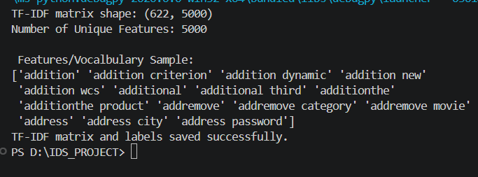
6.4 Insight
TF-IDF helps highlight important words while reducing the impact of common words. Limiting features to 5000 ensures the model remains efficient and avoids overfitting.

7. Model Building & Evaluation
7.1 Objective
The goal of this step is to train a machine learning model that can classify requirements into Functional and Non-Functional categories and evaluate its performance.

7.2 Implementation
Data Splitting
The dataset is split into:
- 80% Training Data
- 20% Testing Data
This ensures the model is tested on unseen data.

Model Selection
A Logistic Regression classifier is used because:
- It is simple and efficient
- Works well for text classification
- Provides reliable baseline performance
The model is configured with:
- class_weight = 'balanced' → handles class imbalance
- max_iter = 1000 → ensures proper convergence

Training
The model is trained using:
- Input: TF-IDF matrix
- Output: Functional vs non-functional labels

7.3 Evaluation
The model is evaluated using:
- Accuracy Score → Overall correctness
- Classification Report:
  - Precision
  - Recall
  - F1-score
- Confusion Matrix (conceptually):
  - Shows correct vs incorrect predictions

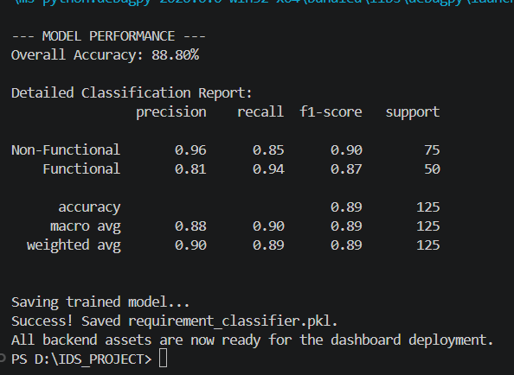

7.4 Insight
The model provides a baseline understanding of classification performance. Using balanced weights helps improve prediction for less frequent classes. Further improvements can be made by testing more advanced models.

7.5 Model Export
The trained model is saved as:
- requirement_classifier.pkl
This allows the model to be reused in deployment without retraining.

Conclusion
The project successfully completed the main steps up to model building. EDA helped us understand the dataset, including class imbalance and overlapping categories. Data cleaning improved the text by removing noise and making it consistent.
TF-IDF was used to convert text into numbers so the model could learn patterns. A Logistic Regression model was then trained and tested, giving a good baseline for classification.
Overall, this work builds a strong foundation for improving the model and moving towards deployment.
The textual processing and model development phases of the project have been completed. However, the backend implementation still requires refinement, and a proper frontend interface is yet to be developed. The next step involves building a Streamlit application that will allow user input and utilize the trained model for real-time classification.

